Pan-Roasted Chicken with Grapes
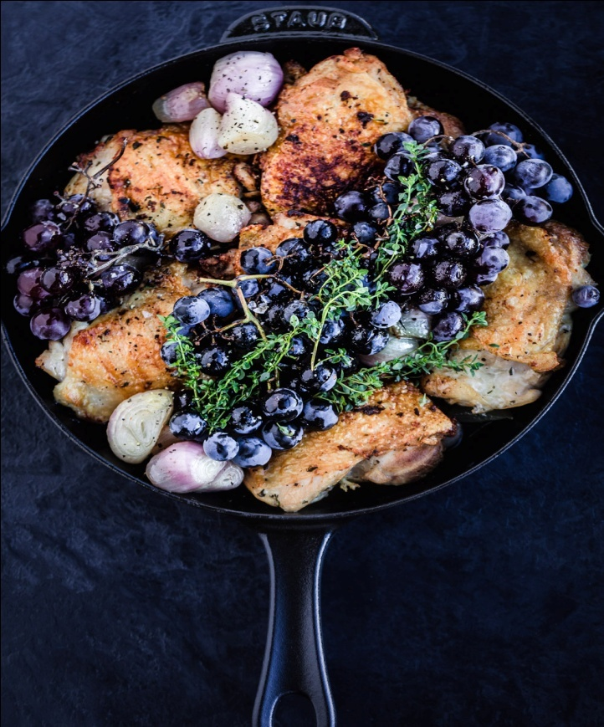
DESCRIPTION:
A delicious recipe for Pan-Roasted Chicken with Grapes. Chicken thighs are pan-seared in a skillet, then baked in the oven with grapes and shallots. A fast and simple weeknight dinner.

INGREDIENTS:
1 tablespoon olive oil
1 garlic clove, smashed
4 chicken thighs, skin-on, bone-in
Salt and pepper to taste
3 fat shallots, sliced lengthwise
1 tablespoon balsamic vinegar ( sherry vinegar, or apple cider vinegar, or any flavorful complementary vinegar)
1 lb seedless grapes ( red), divided into small clusters
1 tablespoon chopped rosemary
Serve with Ginger Whipped Sweet Potatoes
Cook Mode Prevent your screen from going dark

INSTRUCTIONS:
Preheat oven to 400F
If making the Ginger Whipped Sweet Potatoes, get them simmering in a pot.
Heat oil in an oven-proof skillet over medium high heat. Add smashed garlic clove and swirl, to season the oil. Season the skin side of the chicken generously, with salt and pepper, and place skin side down in hot skillet. Season the other side of chicken with salt and pepper, and remove the garlic. Sear skin side until golden and crispy, 6-7 minutes, turning heat to medium. Flip. Place the shallots between the chicken and drizzle with the vinegar. Top with the grape clusters, nestling between and around the chicken. Sprinkle with rosemary and place in the oven for 20 minutes or until internal temp reaches 170F.
While it’s baking, finish making the ginger whipped sweet potatoes.
When chicken seems done, place skillet back the stove and bring it to a quick simmer (just to make sure juices are cooked.) Spoon the whipped sweet potatoes onto plates, top with crispy chicken and divide shallots and grapes among the plates. Spoon some flavorful pan sauce over everything.
Enjoy!

NUTRITION:
Serving Size
:Calories 401Sugar: 18.7 g
Sodium: 398.5 mg
Fat: 24.9 g
Saturated Fat: 6.4 g
Carbohydrates: 23.1 g
Fiber: 1.3 g
Protein: 22.2 g
Cholesterol: 125.2 mg

